David Baldacci



SIMPLE GENIUS

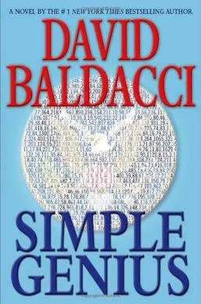

Simple Genius is a thriller novel by American writer [David Baldacci](https://en.wikipedia.org/wiki/David_Baldacci" \o "David Baldacci), which topped the New York Times bestseller list for the week ending April 28, 2007. The book was initially published on April 24, 2007 by [Grand Central Publishing](https://en.wikipedia.org/wiki/Grand_Central_Publishing" \o "Grand Central Publishing).

Simple Genius was described by the [Pittsburgh Post-Gazette](https://en.wikipedia.org/wiki/Pittsburgh_Post-Gazette" \o "Pittsburgh Post-Gazette) as "simply entertaining." Simple Genius continues the story of the characters Michelle Maxwell and Sean King from its predecessors, Split Second and Hour Game, and combines themes such as "quantum computers, protective codes, breaking those codes, the CIA, psychological demons, and even buried treasure.

MEMORY MAN

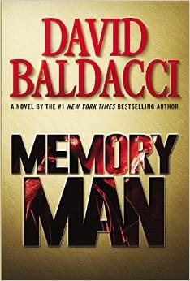

Memory Man is a crime novel about a man whose wife, daughter and brother in law were murdered, written by [David Baldacci](https://en.wikipedia.org/wiki/David_Baldacci" \o "David Baldacci).[[1]](https://en.wikipedia.org/wiki/Memory_Man_(novel)" \l "cite_note-1)[[2]](https://en.wikipedia.org/wiki/Memory_Man_(novel)" \l "cite_note-2) This is the first novel to feature the character Amos Decker.[[3]](https://en.wikipedia.org/wiki/Memory_Man_(novel)" \l "cite_note-3) The novel was released in September 2015 by [Grand Central Publishing](https://en.wikipedia.org/wiki/Grand_Central_Publishing" \o "Grand Central Publishing).

Amos Decker is a former professional football player who was violently hit on his first play, resulting in severe injuries and changes to his brain. As his football career has ended, Decker becomes a police officer, and later a successful detective, while using his newly acquired mental abilities ([synesthesia](https://en.wikipedia.org/wiki/Synesthesia" \o "Synesthesia) and [hyperthymesia](https://en.wikipedia.org/wiki/Hyperthymesia" \o "Hyperthymesia)). After his family is murdered in an unsolved case, Decker loses his will to live, and becomes a transient while working as a [private investigator](https://en.wikipedia.org/wiki/Private_investigator" \o "Private investigator).

After a [mass shooting](https://en.wikipedia.org/wiki/Mass_shooting" \o "Mass shooting) at a local high school, Decker is asked to assist in solving the case by the local police force he used to work for. It soon becomes apparent that the shooting is somehow related to the killing of his family 18 months before.

ABSOLUTE POWER

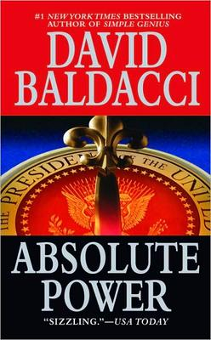

Absolute Power is a [1996 book](https://en.wikipedia.org/wiki/1996_in_literature" \o "1996 in literature) by [David Baldacci](https://en.wikipedia.org/wiki/David_Baldacci" \o "David Baldacci).[[1]](https://en.wikipedia.org/wiki/Absolute_Power_(novel)" \l "cite_note-1) It was made into a [1997 film](https://en.wikipedia.org/wiki/Absolute_Power_(film)" \o "Absolute Power (film)) starring [Clint Eastwood](https://en.wikipedia.org/wiki/Clint_Eastwood" \o "Clint Eastwood). An experienced burglar, Luther Whitney, breaks into a billionaire's house with the intent of robbing it. While there, he witnesses the [President of the United States](https://en.wikipedia.org/wiki/President_of_the_United_States" \o "President of the United States) and the billionaire's wife having sex. However, their lovemaking turns violent and [Secret Service](https://en.wikipedia.org/wiki/United_States_Secret_Service" \o "United States Secret Service) agents burst in and kill the woman, which Whitney also sees. The reason Whitney was able to witness the murder was because he was behind a large one-way mirror that was a secret door into a large closet where the billionaire would sit and watch when his wife had sex with another man. Whitney escapes, but not before the Secret Service learns of his presence; they blame the wife's murder on Whitney. Whitney goes on the run from the President's agents while a detective tries to piece together the crime.

THE WINNER

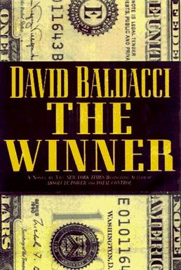

The Winner is fiction novel by American author [David Baldacci](https://en.wikipedia.org/wiki/David_Baldacci" \o "David Baldacci). The book was initially published on January 1, 1998 by [Grand Central Publishing](https://en.wikipedia.org/wiki/Grand_Central_Publishing" \o "Grand Central Publishing). The novel tells the story of LuAnn Tyler, a destitute mother living in a trailer park, who meets with Jackson, a man running a massive lottery scam from inside the National Lottery. He offers her a chance to win the lottery, which she initially refuses until she finds herself falsely accused of murder and needing to run for her life with her young daughter in tow. He rigs the lottery so that she wins $100,000,000, on the condition that she leaves the United States and never returns. When she secretly returns ten years later, Jackson comes to punish her for disobeying him, the FBI is searching for her in connection with the lottery scam, and her only help comes from the mysterious Matthew Riggs.

SAVING FAITH

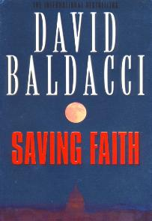

Saving Faith, written by [David Baldacci](https://en.wikipedia.org/wiki/David_Baldacci" \o "David Baldacci), is a [thriller](https://en.wikipedia.org/wiki/Thriller_(genre)" \o "Thriller (genre)) novel set with backdrop of the political [lobbying](https://en.wikipedia.org/wiki/Lobbying_in_the_United_States" \o "Lobbying in the United States), [political corruption](https://en.wikipedia.org/wiki/Political_corruption" \o "Political corruption), and [blackmail](https://en.wikipedia.org/wiki/Blackmail" \o "Blackmail) in the US Government. The book was initially published on November 9, 1999, by [Warner Books](https://en.wikipedia.org/wiki/Warner_Books" \o "Warner Books). The botched attempt on Faith's life led to an all-out hunt for her by three parties – the FBI, the CIA and her boss, Danny Buchanan. Fleeing for her life, Faith was not sure who she can trust, including the stranger Lee Adams who saved her life and admitted being hired to watch her.

While Faith was on the run, Buchanan planned on turning tables on Thornhill before it was too late, but found himself outclassed as an amateur against a professional spook.

Meanwhile, the FBI began to look among their staff for a traitor, with suspicions falling to the dead agent, and Brooke Reynolds.

Despite the setbacks, Thornhill began masterminding several separate moves to deal with Buchanan, Faith and the FBI.

WISH YOU WELL



Wish You Well is a novel written by [David Baldacci](https://en.wikipedia.org/wiki/David_Baldacci" \o "David Baldacci). First published in 2001, the story starts with the Cardinal family planning to move from New York to California due to money problems, then shifts to the mountains of Virginia after a car accident leaves the father dead and the mother in a catatonic state. The time period is in the 1940s.

The novel was made into a 2013 [theatrical film](https://en.wikipedia.org/wiki/Wish_You_Well_(film)" \o "Wish You Well (film)) scripted by Baldacci and starring [Mackenzie Foy](https://en.wikipedia.org/wiki/Mackenzie_Foy" \o "Mackenzie Foy) and [Ellen Burstyn](https://en.wikipedia.org/wiki/Ellen_Burstyn" \o "Ellen Burstyn) as a granddaughter and grandmother. Foy and Burstyn both portrayed the character "Murph," at radically different ages, in the film [Interstellar](https://en.wikipedia.org/wiki/Interstellar_(film)" \o "Interstellar (film)) the following year.

LAST MAN STANDING

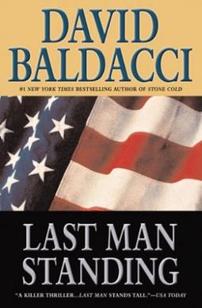

Last Man Standing is a thriller novel written by [David Baldacci](https://en.wikipedia.org/wiki/David_Baldacci" \o "David Baldacci). The book was initially published on November 6, 2001 by [Grand Central Publishing](https://en.wikipedia.org/wiki/Grand_Central_Publishing" \o "Grand Central Publishing).[[1]](https://en.wikipedia.org/wiki/Last_Man_Standing_(novel)" \l "cite_note-1)[[2]](https://en.wikipedia.org/wiki/Last_Man_Standing_(novel)" \l "cite_note-2) The novel follows the protagonist, Web London, through a series of harrowing events. London is the only member of his elite FBI [Hostage Rescue Team](https://en.wikipedia.org/wiki/Hostage_Rescue_Team" \o "Hostage Rescue Team) unit to survive after they are ambushed when executing a high risk raid against an apparent drug operation.

THE SIXTH MAN

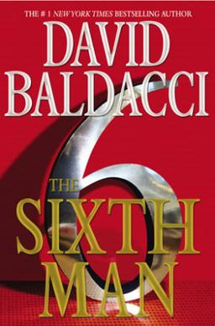

The Sixth Man is a [crime fiction](https://en.wikipedia.org/wiki/Crime_fiction" \o "Crime fiction) novel by American writer [David Baldacci](https://en.wikipedia.org/wiki/David_Baldacci" \o "David Baldacci). The book was initially published on April 19, 2011 by [Grand Central Publishing](https://en.wikipedia.org/wiki/Grand_Central_Publishing" \o "Grand Central Publishing). This is the fifth installment in the [King and Maxwell book series](https://en.wikipedia.org/wiki/King_and_Maxwell_(book_series)" \o "King and Maxwell (book series)). Sean King and Michelle Maxwell are called to help Edgar Roy, an alleged [serial killer](https://en.wikipedia.org/wiki/Serial_killer" \o "Serial killer) awaiting trial. Roy faces almost certain conviction. Roy’s attorney, Sean’s friend and mentor Ted Bergin, is set to meet with King and Maxwell to help work the case. But their investigation is derailed when Sean and Michelle find Bergin murdered on a quiet highway in New England. King and Maxwell uncover a secret government program which uses analysts to examine the combined intelligence government channels and offer strategic advice. Roy was the top such analyst. King and Maxwell are aided by Roy's half sister, a former spy. The trio uncover a conspiracy by the [Secretary of Homeland Security](https://en.wikipedia.org/wiki/Secretary_of_Homeland_Security" \o "Secretary of Homeland Security) to shut down the program and have Roy executed. The novel ends with Michelle waking from a coma after the final battle and Sean realizing how much their relationship meant to him.

THE COLLECTORS



The Collectors is a [thriller](https://en.wikipedia.org/wiki/Thriller_(genre)" \o "Thriller (genre)) novel written by American author [David Baldacci](https://en.wikipedia.org/wiki/David_Baldacci" \o "David Baldacci). The book was published by [Warner Books](https://en.wikipedia.org/wiki/Warner_Books" \o "Warner Books) on October 17, 2006.[[1]](https://en.wikipedia.org/wiki/The_Collectors_(novel)" \l "cite_note-1)[[2]](https://en.wikipedia.org/wiki/The_Collectors_(novel)" \l "cite_note-2) This is the second installment to feature the [Camel Club](https://en.wikipedia.org/wiki/Camel_Club" \o "Camel Club), a small group of [Washington, D.C.](https://en.wikipedia.org/wiki/Washington,_D.C." \o "Washington, D.C.) civilian misfits led by "[Oliver Stone](https://en.wikipedia.org/wiki/Camel_Club" \l "Camel_Club_original_members" \o "Camel Club)", an ex-[Green Beret](https://en.wikipedia.org/wiki/United_States_Army_Special_Forces" \o "United States Army Special Forces) and a former [CIA](https://en.wikipedia.org/wiki/Central_Intelligence_Agency" \o "Central Intelligence Agency) trained assassin. On November 5, 2006, the novel debuted at No. 2 on [The New York Times Best Seller list](https://en.wikipedia.org/wiki/The_New_York_Times_Best_Seller_list" \o "The New York Times Best Seller list)[[3]](https://en.wikipedia.org/wiki/The_Collectors_(novel)" \l "cite_note-charts1-3) and remained on the list for seven weeks.